1. Launcher installer, proceed to Install.

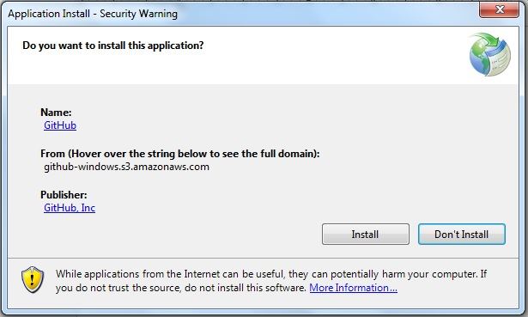

2. Allow launcher to download resources

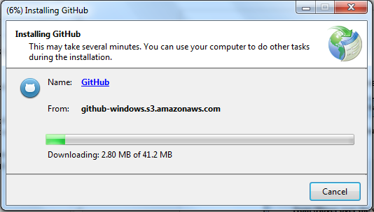

3. Go to a github online repository and fork the repository.

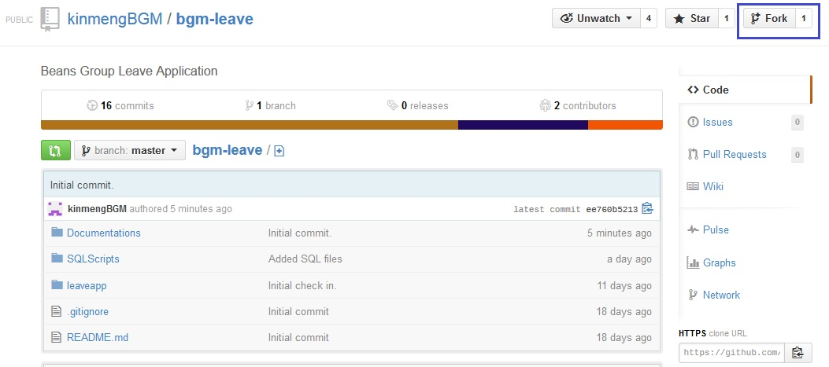

4. Clone into local repository after fork.

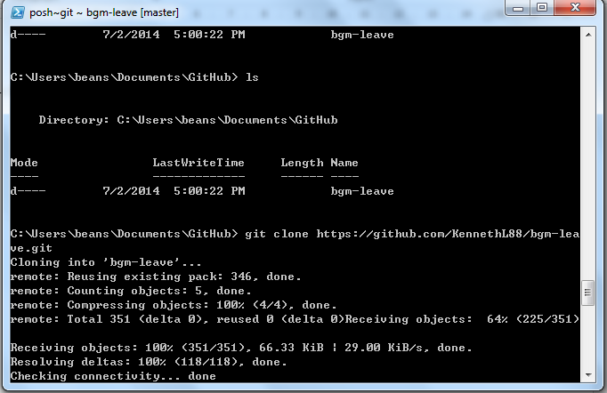

5.